North Star Wireless
Windows 11 Initial Setup
INTERNAL USE ONLY: This guide contains setup credentials. Do not share it outside North Star Wireless.
STEP 1 | Start the Dell and follow the first prompts
Choose your country or region, confirm the keyboard layout, and skip a second keyboard layout unless you need one.
Before you continue: Confirm the computer is running Windows 11 Pro. The Work or School and Domain join instead choices may not appear on Windows 11 Home.
STEP 2 | Connect to North Star Wi-Fi
On the Let's connect you to a network screen, select North Star Wi-Fi, select Connect, and enter the password exactly as shown below.
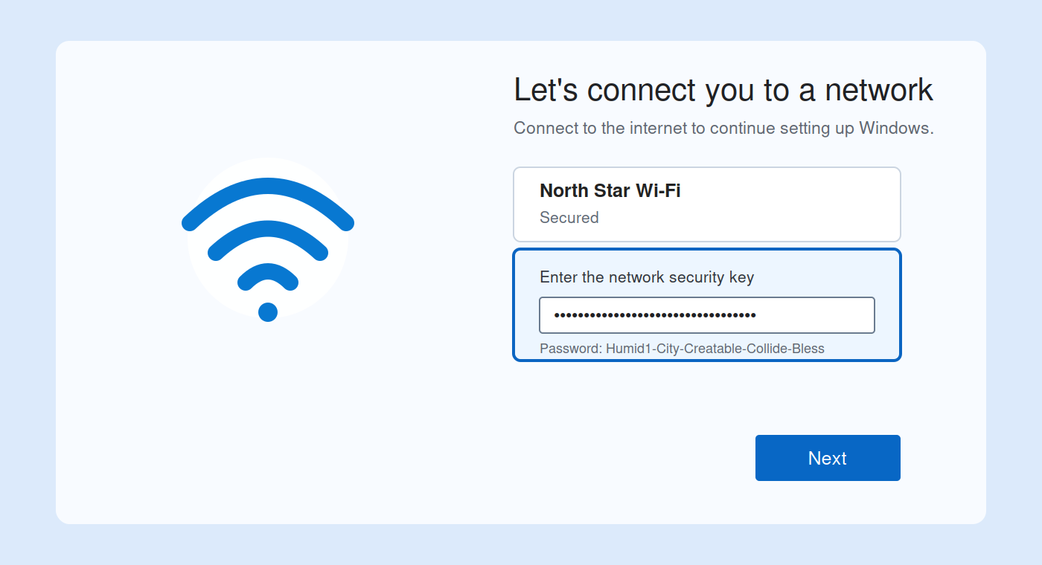
Wi-Fi password: Humid1-City-Creatable-Collide-Bless

STEP 3 | Name the device using the Dell Service Tag
On the Let's name your device screen, enter the Dell Service Tag and select Next. Windows may restart before setup continues.
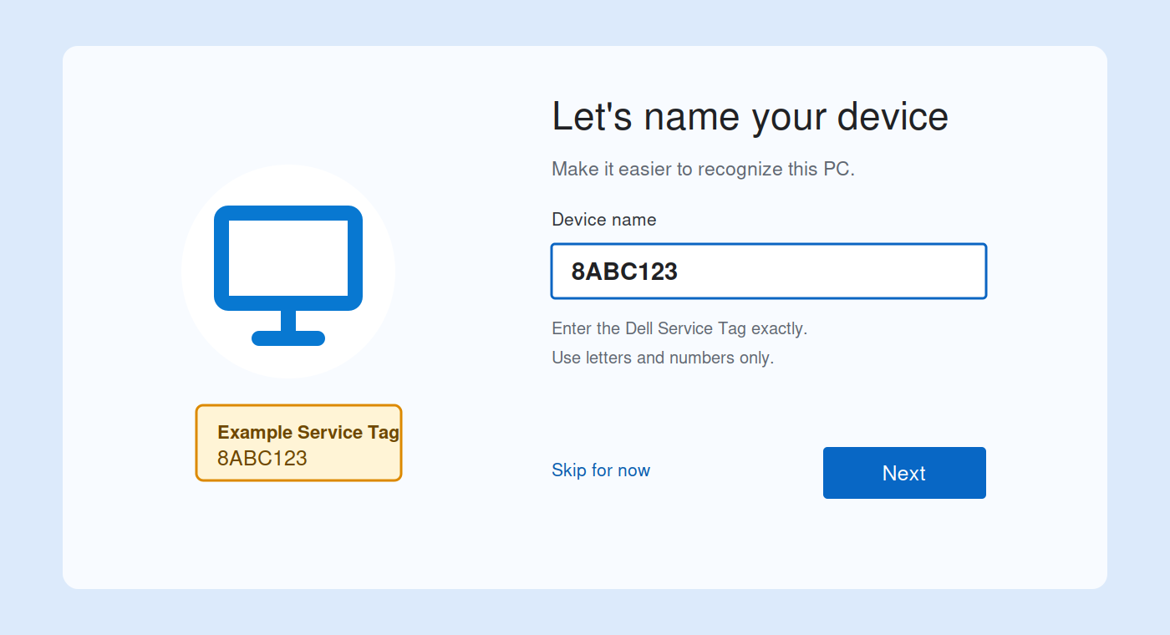
Use the Service Tag only. It is usually 7 characters on the Dell label (example: 8ABC123). Do not use the Express Service Code, store name, or employee name.
Do not select Skip for now. The computer must be named during Windows setup.

Choose the Work Setup Path
STEP 4 | Work or School  Select the lower tile: Set up for work or school. Then select Next.  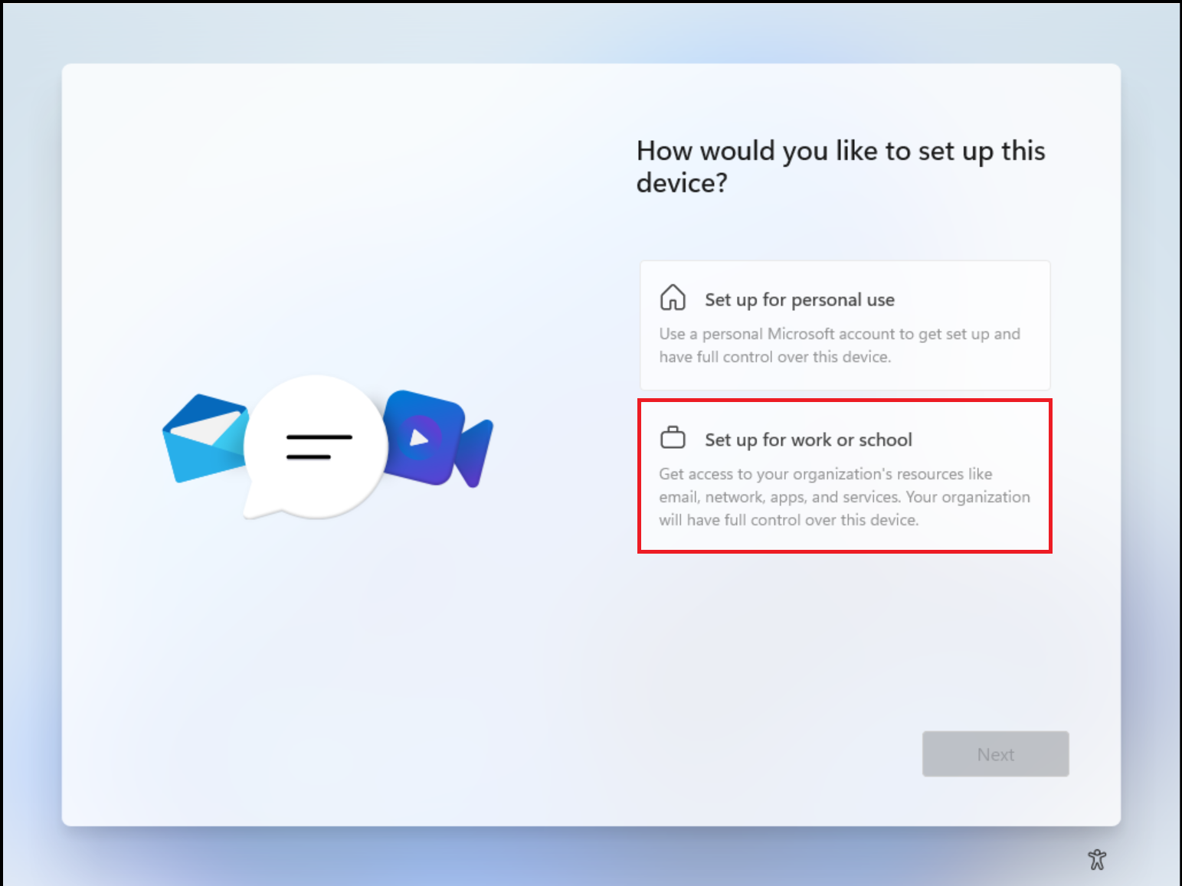  Do not choose Set up for personal use. | STEP 5 | Sign-in options  Leave the email field blank. Select Sign-in options. It may say Other sign-in options.  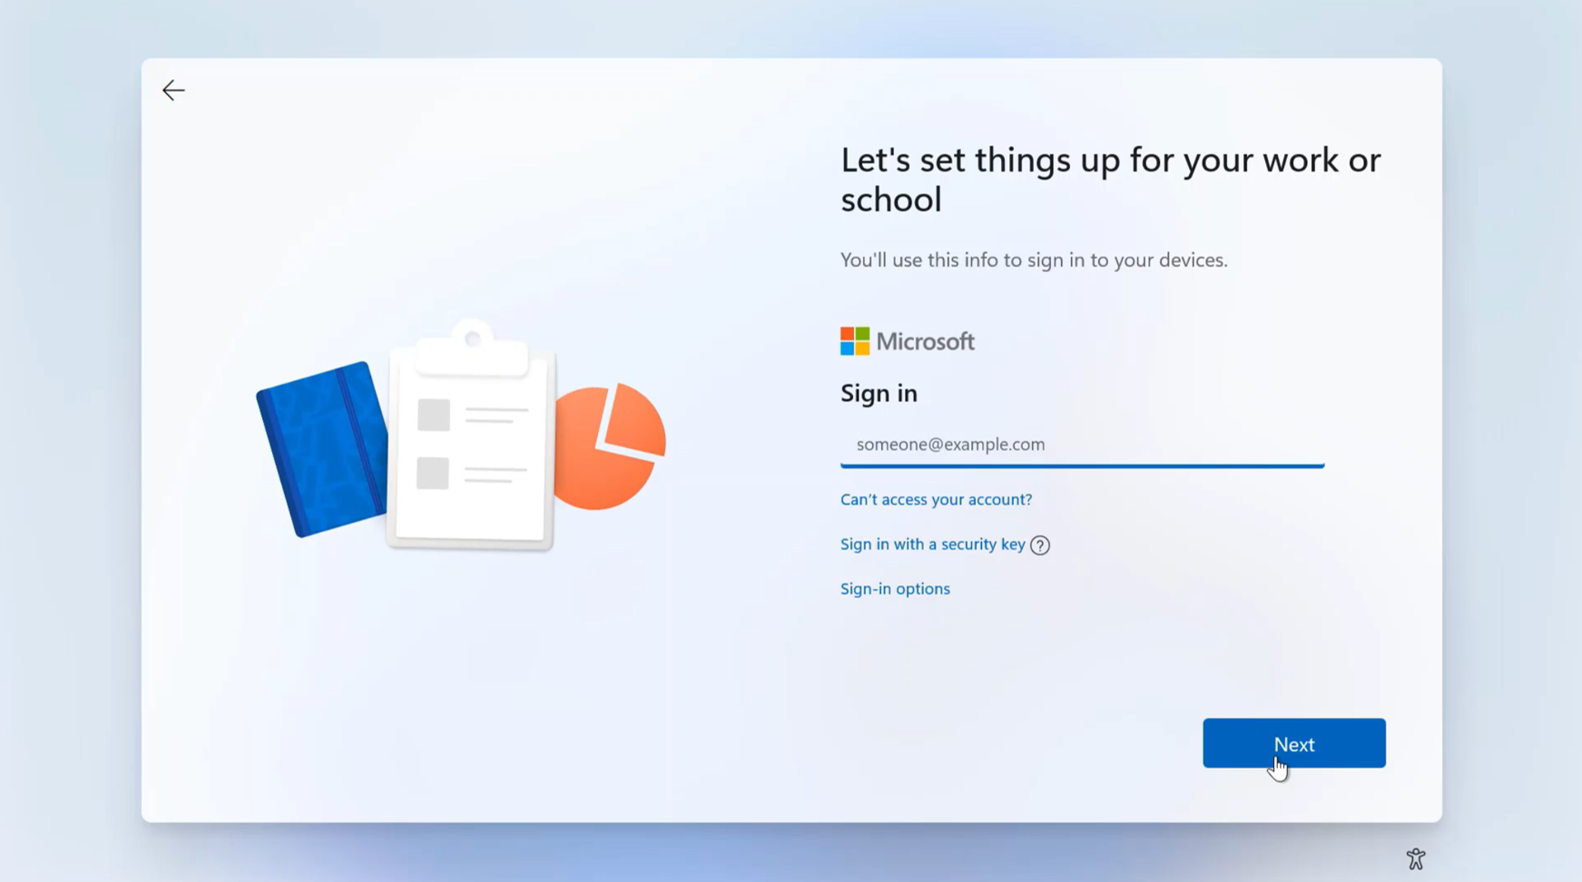  Do not enter an email address.
The important sequence is: Set up for work or school > Sign-in options > Domain join instead.

STEP 6 | Choose Domain join instead
Select Domain join instead. The wording is confusing: this choice does not require you to enter a domain. It opens the local Windows account setup.
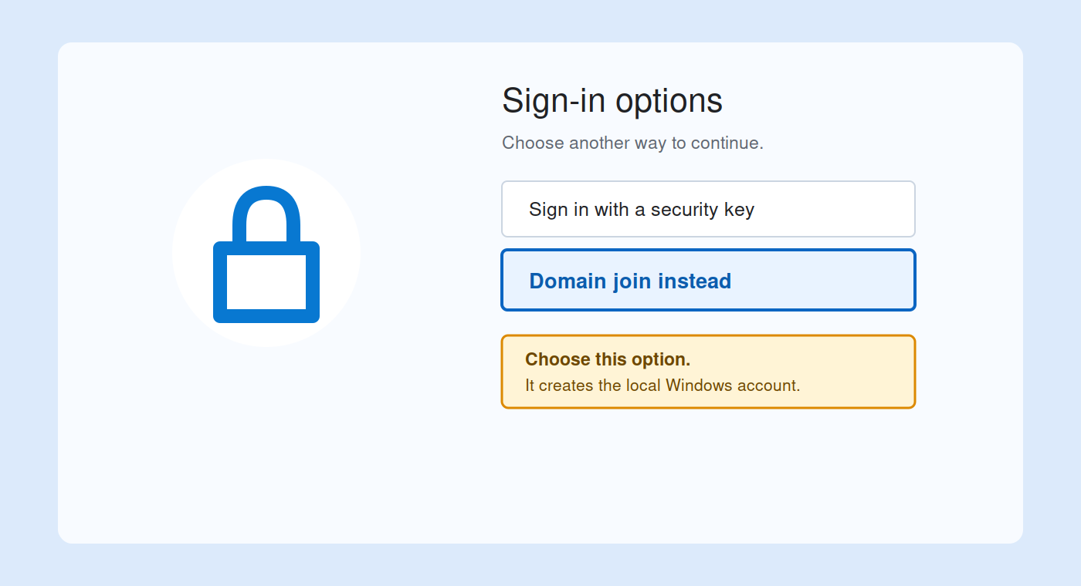
STEP 7 | Create the NSWAdmin local administrator
On Who's going to use this device?, type NSWAdmin and select Next. On the password screen, enter 2026, select Next, and enter it again when asked to confirm.
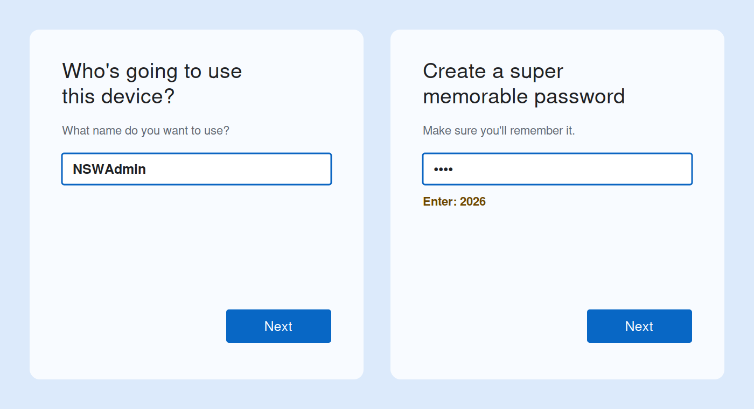
Use exactly: Username NSWAdmin | Password 2026
STEP 8 | Finish Windows setup
If Windows asks security questions, choose three questions and enter answers you can remember. Continue through the privacy settings until the Windows desktop appears. The computer is already named; do not rename it again in Settings.

STEP 9 | Download and install Action1
At the Windows desktop, open Microsoft Edge. Select the address bar, type the short address shown below, and press Enter. The North Star Action1 installer will download.
TYPE THIS IN MICROSOFT EDGE
tinyurl.com/nsw-action-one
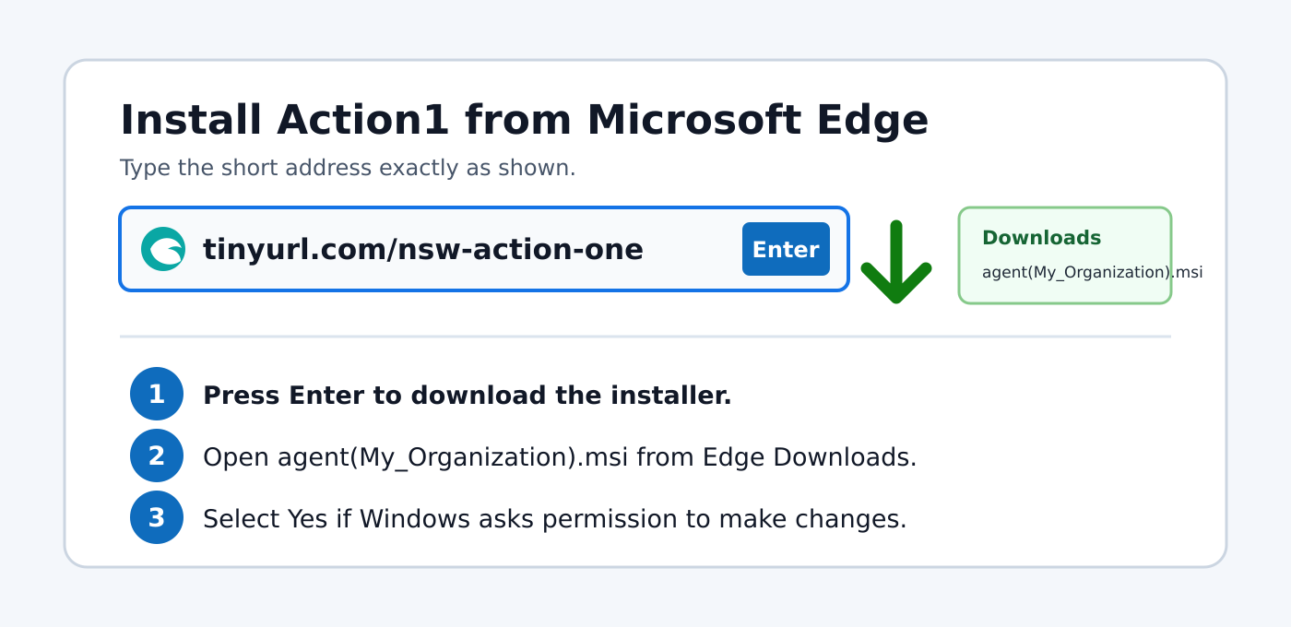
Open the downloaded file named agent(My_Organization).msi. If User Account Control asks Do you want to allow this app to make changes to your device?, select Yes.
The installer may close without a confirmation screen. Leave the PC powered on, signed in, and connected to North Star Wi-Fi for at least 15 minutes.
STEP 10 | Stop here
Do not install other applications or add a personal Microsoft account. North Star IT will use Action1 to complete the remaining setup remotely.

Quick Reference
Item | What to use
Wi-Fi | North Star Wi-Fi
Wi-Fi password | Humid1-City-Creatable-Collide-Bless
Setup type | Set up for work or school
Local setup path | Sign-in options > Domain join instead
Local username | NSWAdmin
Local password | 2026
Device name during setup | Dell Service Tag only
Action1 installer | tinyurl.com/nsw-action-one
STEP A | If your screen looks different
Windows may show the naming screen in a slightly different order. Enter the Dell Service Tag whenever Let's name your device appears. If Domain join instead is missing, confirm the computer has Windows 11 Pro. Do not enter a personal Microsoft account to get around the screen.
STEP B | Before you leave the computer
☐ The PC name matches the Dell Service Tag.
☐ The PC is connected to North Star Wi-Fi.
☐ Action1 has been installed.
☐ The PC is plugged into power and left turned on for at least 15 minutes.
Security reminder: This guide contains internal credentials. Store it securely and do not forward it outside North Star Wireless.

